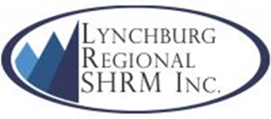

Applicant’s Name:__________________________
Type of Scholarship: ___ Student Scholarship ___ Certification Scholarship
Score: _____

Student Scholarship Rubric | Outstanding | Moderate | Minimal | Not Present
 | 3 | 2 | 1 | 0
National SHRM Member | Yes | n/a | n/a | No
Student Chapter SHRM Member | Yes | n/a | n/a | No
Student Chapter Activity/Participation | 85-100% | 65-84% | 50-64% | Less than 50%
Degree | HR or Related Degree declared | n/a | n/a | Non-HR degree declared
Education | 3 or more HR-related courses completed | 2 HR-related courses completed | 1 HR-related course completed | 0 HR-related college classes completed
HR Related Work Experience/Internship | Yes | n/a | n/a | No
Total:

Certification Scholarship Rubric | Outstanding | Moderate | Minimal | Not Present
 | 3 | 2 | 1 | 0
National SHRM Member | Yes | n/a | n/a | No
Local Chapter Member | Yes | n/a | n/a | No
Local Chapter Activity/Participation | 85-100% | 65-84% | 50-64% | Less than 50%
Certification/Recertification | Yes | n/a | n/a | No
Total:

